Kaggle notes

Encountering the following

Error in table(vote.train$Party, PredTest > 0.5) :

all arguments must have the same length

Reason – predicted values of NA in numeric vector

Let’s see

**tapply**

is similar to GROUP BY with an aggregate function in SQL

First argument: the numerical variable you want to **apply** the aggregate function

Second argument: the categorical variable you want to aggregate **by**

Third argument: the aggregate function you want to **apply**

tapply(mtcars$mpg,mtcars$carb,mean)

1 2 3 4 6 8

25.34286 22.40000 16.30000 15.79000 19.70000 15.00000

**by multiple categorical variable**

you can supply multiple categorical variables to the sapply function in the form of a *list*:

translation: average mpg BY cylinder(cyl) and gears(gear):

tapply(mtcars$mpg,list(mtcars$cyl,mtcars$gear),mean,na.nm=TRUE)

3 4 5

4 21.50 26.925 28.2

**Gear**

6 19.75 19.750 19.7

8 15.05 NA 15.4

**Cylinders**

#merge the CPS dataset with the MetroAreaMap

CPS = merge(CPS, MetroAreaMap, by.x="MetroAreaCode", by.y="Code", all.x=TRUE)

First argument: first data frame to combine (implied alias of “x”)

Second argument: second data frame to combine (implied alias of “y”)

Third argument: variable in first data frame to merge by. **This is the common field to both data frames**

Fourth argument: variable in second data frame to merge by. **This is the common field to both data frames**

Fifth argument (all.x=TRUE) – analogous to a JOIN type in SQL (inner, outer)

If TRUE will return ALL rows in the x alias, regardless of a match (same a LEFT OUTER JOIN in SQL)

Analyics edge

use abline to create

plot(CocaCola$Date[301:432], CocaCola$StockPrice[301:432], type="l", col="red", ylim=c(0,210))

lines(ProcterGamble$Date, ProcterGamble$StockPrice,col="Blue")

lines(IBM$Date, IBM$StockPrice,col="Green")

lines(Boeing$Date, Boeing$StockPrice,col="Black")

lines(GE$Date, GE$StockPrice,col="Orange")

abline(v=as.Date(c("1997-09-01")), lwd=2)

abline(v=as.Date(c("1997-11-01")), lwd=2)

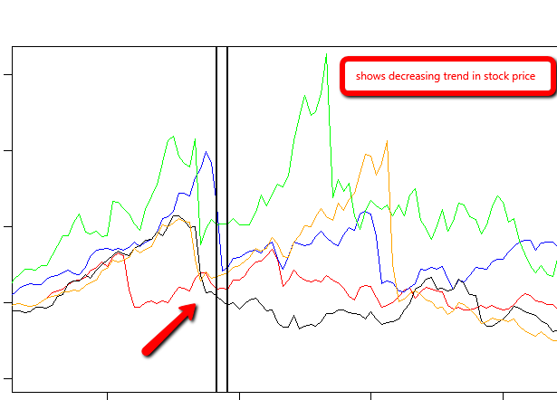

**week 1 R**

**Command FAQ**

|  |  |
| --- | --- |
| Get working directory | getwd()  > getwd()  [1] "D:/win7docs" |
| list objects in workspace | > ls()  [1] "complx" "x" "y" |
| list all files in working directory | dir() OR  list.files() |
| set working directory | setwd(“path”) |
| get information about a file | file.info("mytest.R")  size isdir mode mtime ctime atime exe  mytest.R 0 FALSE 666 2016-02-28 21:11:56 2016-02-28 21:11:56 2016-02-28 21:11:56 no |
|  |  |

**todo**

* read through some in the “Some R resources” slide in Overview and HIstory of R
* and also the “Some Useful Books on S/R” slide
* read “how to ask questions the smart way”
* load best R manuals into dropbox so you can read and annotate in goodreader
* **ORDER A STYLUS!!!!**

S language developed at Bell Labs.

R is an implementation of the S language..

about 4,000 packages developed by users around the world

CRAN

* has a number a quality standards: documentation, passes certain number of tests

Bioconductor project - genomic and biological data analysis

**Help**

discussion boards

email

answer sources:

manual

FAQ

goodle

**checklist when asking questions:**

* say what you did (FAQ, read manual, google, forum)
* reproduce problem
* version of R running
* which OS
* additional information

**Places to turn**

* class discussion forum
* [r-help@r-project.org](mailto:r-help@r-project.org)

**R OBJECTS**

**“Atomic” classes – the lowest level**

* character
* numeric (Real numbers)
* integer
* complex
* logical (true/false)

most basic object is a **vector**

**Vector**

* a vector can only contain objects of the **same class**
* EXCEPTION - a **list** contain objects of different classes

**List**

Any element of a list can be anything

* A list within a list

create an empty vector: use the **vector function**

**Example**

Creates an empty vector z or numeric objects, with a length of 100:

z<-vector(mode="numeric", length=100)

|  |
| --- |
| > ##creates empty vector  > z<-vector(mode="numeric", length=10)  > str(z)  num [1:10] 0 0 0 0 0 0 0 0 0 0  > z  [1] 0 0 0 0 0 0 0 0 0 0 |
|  |
| |  | | --- | | > | |

**Numbers**

* Number default to numeric objects (real numbers) as opposed to integers
* Explicit integer: use the L suffix
* Inf – represents *infinity*
* NaN – undefined value “non a number”

**Attributes**

* R objects can have an attribute
* Not every object have them
* names, dimnames
* dimensions (e.g. matrices, arrays)
* class
* length
* user-defined

Attributes can be accessed using the attributes() function

**console:**

> x<-5

> str(x)

num 5

> y<-5L

> str(y)

int 5

The output type is determined from the highest type of the components in the hierarchy

NULL < raw < logical < integer < double < complex < character < list < expression

^^^^^^^^^^ ^^^^^^^^^^^

**lowest on tree highest on tree**

**SO,**

list trumps logical

character trumps logical

integer trumps logical

logical trumps null,

and so on

> y<-c(1.7,'x') ##character vector

> str(y)

chr [1:2] "1.7" "x"

> y<-c(TRUE,1) ##numeric vector

> str(y)

num [1:2] 1 1

> y<-c("x",TRUE) ##character vector

> str(y)

chr [1:2] "x" "TRUE"

Coercion

When you call a function with an argument of the wrong type, R will try to coerce values to a different type so that the function will work. There are two types of coercion that occur automatically in R: coercion with formal objects and coercion with built-in types.

With generic functions, R will look for a suitable method. If no exact match exists, then R will search for a coercion method that converts the object to a type for which a suitable method does exist. (The method for creating coercion functions is described in [Creating Coercion Methods](https://www.safaribooksonline.com/library/view/r-in-a/9781449358204/ch10s02.html#coercion-methods).)

Additionally, R will automatically convert between built-in object types when appropriate. R will convert from more specific types to more general types. For example, suppose that you define a vector x as follows:

> **x <- c(1, 2, 3, 4, 5)**  
> **x**  
[1] 1 2 3 4 5  
> **typeof(x)**  
[1] "double"  
> **class(x)**  
[1] "numeric"

Let’s change the second element of the vector to the word “hat.” R will change the object class to character and change all the elements in the vector tochar:

> **x[2] <- "hat"**  
> **x**  
[1] "1" "hat" "3" "4" "5"   
> **typeof(x)**  
[1] "character"  
> **class(x)**  
[1] "character"

Here is an overview of the coercion rules:

* Logical values are converted to numbers: TRUE is converted to 1 and FALSEto 0.
* Values are converted to the simplest type required to represent all information.
* The ordering is roughly logical < integer < numeric < complex < character < list.

**nonsensical coercion**

You cannot convert certain object from one to another

* a character cannot convert to an integer
* a character cannot convert to a logical
* will result in error message “NAs introduced by coercion”

> ##explicit coerciion

> ##nonsensical results

> x<-c("a","b","c")

> as.numeric(x)

[1] NA NA NA

Warning message:

NAs introduced by coercion

> as.logical(x)

[1] NA NA NA

> as.complex(x)

[1] NA NA NA

Warning message:

NAs introduced by coercion

**Lists**

> x<-list(1,"a",TRUE,1+4i)

> x

[[1]] <<<<<<< **elements of a list will have double brackets around them**

[1] 1

[[2]]

[1] "a"

[[3]]

[1] TRUE

[[4]]

[1] 1+4i

**Matrices**

* special type of vector in R
* vectors that have an attribute called a *dimension*

Create matrix by using the **matrix** function:

- Creates an empty matrix of 2 rows and 3 columns

- dim(m) will return the dimension attribute where the

* first number – number of rows
* second number – number of columns

-attributes() function will return a ***list*** where the first element is the dim element, which has the vector 2,3

|  |
| --- |
| > ##matrices  > m<-matrix(nrow=2,ncol=3)  > m  [,1] [,2] [,3]  [1,] NA NA NA  [2,] NA NA NA  > dim(m)  [1] 2 3  > attributes(m)  $dim  [1] 2 3 |
|  |
| |  | | --- | | > | |

**Matrices**

* are a vector with a dimension attribute

**Creating and populating a matrix**

* is populated *column-wise*
* this means *down* then *across*
* the below code shows the creation of a matrix, filling with the integer sequence 1-6, with 2 rows and 3 columns

|  |
| --- |
| > ##creating and populating a matrix  > m<-matrix(1:6,nrow=2,ncol=3) <<<<< shows a new argument to the matrix function  > m  [,1] [,2] [,3]  [1,] 1 3 5  [2,] 2 4 6 |
| **Creating a matrix by CONVERTING a vector into a matrix:** |
| |  | | --- | |  | |
| > ##another way of creating a matrix  > m<-1:10  > ##this creates a VECTOR of numbers 1-10:  > m  [1] 1 2 3 4 5 6 7 8 9 10  > ##call the dim function to the vector  > ##dim(m)<-c(2,5) will CONVERT the vector into  > ##a matrix of 2 rows and 5 columns  > dim(m)<-c(2,5)  > m  [,1] [,2] [,3] [,4] [,5]  [1,] 1 3 5 7 9  [2,] 2 4 6 8 10  **Creating a matrix by using cbind or rbind**   * cbind will fill the matrix columns-first * rbind will fill the matrix rows-first   > ##yet another way of creating a matrix  > x<-1:3  > y<-10:12  > cbind(x,y)  x y  [1,] 1 10  [2,] 2 11  [3,] 3 12  > rbind(x,y)  [,1] [,2] [,3]  x 1 2 3  y 10 11 12 |
|  |
| |  | | --- | | > | |

**Factors**

1. used to represent categorical data
2. can be ordered an unordered
   1. ordered (also called *ordinal* in statistics). Examples:
      1. levels of education : high school, some college, 4 years college, ect
      2. ratings of a restaurant 1-10
      3. income levels 0-$10,000,>$10,000-20,000 ect
   2. unordered: states, sex (M/F)
3. **IMPORTANT –** used for modeling functions in R, graphing as well

> ##factors

> x<-factor(c("yes","no","no","yes","no"))

> x

[1] yes no no yes no

Levels: no yes

> table(x) ##gives frequency count

x

no yes

3 2

>

> unclass(x) ##strips out the class of a vector

[1] 2 1 1 2 1

attr(,"levels")

[1] "no" "yes"

> - ##brings down to an integer vector

> ##represented INTERNALLY by R as 1's and 2's

> x

[1] yes no no yes no

Levels: no yes

> str(x)

Factor w/ 2 levels "no","yes": 2 1 1 2 1

**Setting levels explicitly with the levels argument**

|  |
| --- |
| > ##orders of levels can be set using the levels argument of the factor() function  >  > x<-factor(c("yes","yes","no","yes","no"),  + levels=c("yes","no"))  > ##in x, "yes" is the baseline due to the explicit declaration  > ## using the levels argument  > x  [1] yes yes no yes no  Levels: yes no  > nolevel<-factor(c("yes","yes","no","yes","no"))  > ##without the levels argument, "no" is the baseline  > ##due to alphabetical order  > nolevel  [1] yes yes no yes no  Levels: no yes |
|  |
| |  | | --- | |  | |

**Missing values**

* Is

**Data frames**

* Special type of list – seems similar to database tables
* Data frames can store different objects with different classes, **unlike a matrix**
* Usually created with read.table(), read.csn

|  |
| --- |
| > ##Data frame - used to store tabular data  > ##a special type of list  > ##each element - column - each  > x<-data.frame(foo=1:4, bar=c(T,T,F,F))  > ##prints out frame, with now row names, as none were specified  > x  foo bar  1 1 TRUE  2 2 TRUE  3 3 FALSE  4 4 FALSE  > nrow(x)  [1] 4  > ncol(x)  [1] 2 |
|  |
| |  | | --- | | > | |

**Names**

* R objects can have names – useful for writing reusable code and self-describing objects

> ##lists can also have names

> ##create list - 1st element called 1

> ##second element called b

> ##third element is called c

> x<-list(a=1,b=3,c=3)

> ##printout shows names of each element and the

> ##values associated with those names

> x

$a

[1] 1

$b

[1] 3

$c

[1] 3

**Reading data**

|  |  |  |
| --- | --- | --- |
| **Read** | **Write** | **Description** |
| read.table read.csv | write.table | reading tabular data |
| readLines | writeLines | reading lines of a text file |
| source | dump | reading R code files |
| Dget | dput | reading R code files? |
| load | save | reading in saved workspaces |
| unserialize | serialize | reading R objects in serial form |

**read.table**

<insert full description from Peng’s presentation>

* file – the name of a file
* header – does first line have variable names
* *sep*, delimiter – comma, tab
* colClasses – character vector – specify the class of each object in the data **NOT REQUIRED**
* nrows – number of rows in dataset **NOT REQUIRED**
* comment.char – character string indicating comment character – default is # character – you can specify other characters
* skip - # of lines to skip – if there is non-data information you can skip
* stringsAsFactors, defaults as true.. if a value is character – it defaults as character

R automatically

* skips lines that begin with a #
* figures out how many rows
* determine type of variable . **telling R directly is more efficient and faster**
* read.csv is identical to read.table, except default separator is a comma
* default separator in read.table is space
* defaults to header=true

**Larger datasets**

* read help page for read.table
* calculate how large the input file is – if larger than memory in computer, stop
* use the colClasses argument. – MUCH FASTER
* know system
  + OS 32 or 64 – 64 access more memory

**Calculating memory**

* will need more physical memory than this calculation requires
* **double** the memory is a rule of thumb

data frame 1,500,000 rows, 120 columns, all numeric

**formula:**

rows * columns * storage per field

1,500,000 x 120 x 8 bytes/numeric

=1,440,000,000 bytes

=1,440,000,000 / 220  bytes/MB

=1,373.29 MB

=1.34 GB

> initial<-read.csv("mtcars.csv",nrows=10)

> #sapply - loops over the columns

> # while calling the class function

> # the class function will tell you what class

> # of data is in each column

> classes<-sapply(initial,class)

> tabAll<-read.csv("mtcars.csv",

+ colClasses=classes)

> initial

X mpg cyl disp hp drat wt qsec vs am gear carb

1 Mazda RX4 21.0 6 160.0 110 3.90 2.620 16.46 0 1 4 4

2 Mazda RX4 Wag 21.0 6 160.0 110 3.90 2.875 17.02 0 1 4 4

3 Datsun 710 22.8 4 108.0 93 3.85 2.320 18.61 1 1 4 1

4 Hornet 4 Drive 21.4 6 258.0 110 3.08 3.215 19.44 1 0 3 1

5 Hornet Sportabout 18.7 8 360.0 175 3.15 3.440 17.02 0 0 3 2

6 Valiant 18.1 6 225.0 105 2.76 3.460 20.22 1 0 3 1

7 Duster 360 14.3 8 360.0 245 3.21 3.570 15.84 0 0 3 4

8 Merc 240D 24.4 4 146.7 62 3.69 3.190 20.00 1 0 4 2

9 Merc 230 22.8 4 140.8 95 3.92 3.150 22.90 1 0 4 2

10 Merc 280 19.2 6 167.6 123 3.92 3.440 18.30 1 0 4 4

> classes

X mpg cyl disp hp drat wt

"factor" "numeric" "integer" "numeric" "integer" "numeric" "numeric"

qsec vs am gear carb

"numeric" "integer" "integer" "integer" "integer"

> tabAll

X mpg cyl disp hp drat wt qsec vs am gear carb

1 Mazda RX4 21.0 6 160.0 110 3.90 2.620 16.46 0 1 4 4

2 Mazda RX4 Wag 21.0 6 160.0 110 3.90 2.875 17.02 0 1 4 4

3 Datsun 710 22.8 4 108.0 93 3.85 2.320 18.61 1 1 4 1

4 Hornet 4 Drive 21.4 6 258.0 110 3.08 3.215 19.44 1 0 3 1

5 Hornet Sportabout 18.7 8 360.0 175 3.15 3.440 17.02 0 0 3 2

6 Valiant 18.1 6 225.0 105 2.76 3.460 20.22 1 0 3 1

7 Duster 360 14.3 8 360.0 245 3.21 3.570 15.84 0 0 3 4

8 Merc 240D 24.4 4 146.7 62 3.69 3.190 20.00 1 0 4 2

9 Merc 230 22.8 4 140.8 95 3.92 3.150 22.90 1 0 4 2

10 Merc 280 19.2 6 167.6 123 3.92 3.440 18.30 1 0 4 4

11 Merc 280C 17.8 6 167.6 123 3.92 3.440 18.90 1 0 4 4

**Textual formats**

* dumping and dputing
* preserve the *metadata* of the data
* better for version control – like Subversion or Git
* can be longer-lived
* adhere to the “Unix” philosophy
* Downside: not space efficient

**dput-ting R Objects**

> ##dput-ting writes out data AND metadata to a file

> y<-data.frame(a=1,b="a")

> dput(y)

structure(list(a = 1, b = structure(1L, .Label = "a", class = "factor")), .Names = c("a",

"b"), row.names = c(NA, -1L), class = "data.frame")

> dput(y,file="y.R") ##saves structure to a file - writes R code which can

> ##reconstruct an R object

> new.y<-dget("y.R")

> new.y

a b

1 1 a

**Dumping R Objects**

Multiple objects can be deparsed using the dump function and read back in using source

|  |
| --- |
| > #dumping R objects - can save MULTIPLE R objects  > # create two objects, x and y, dump to file, remove, then  > # read back in  > x<-"foo"  > y<-data.frame(a=1,b="a")  > dump(c("x","y"),file="datadump.R")  > rm(x,y) #removes objects from memory  > source("datadump.R")  > y  a b  1 1 a  > x  [1] "foo" |
|  |
| |  | | --- | | > | |

**Interfaces to outside world:**

connections *abstract out*the specifics of connecting to the specific data sources

* file, opens a connection to a file
* gzfile, opens a connection to a file compressed with gzip
* bzfile, opens a connection to a file compressed with bzip2
* url, opens a connection to a webpage

**File Connections**

> str(file)

function (description = "", open = "", blocking = TRUE, encoding = getOption("encoding"),

raw = FALSE)

* description – name of file
* open is a code indicating
* “r” read only
* “w” writing and initializing a new file
* “a” appending
* “rb”,”wb”,”ab” reading, writing, or appending in binary mode
* **see help for details**

**Connections**

* in many cases you do not need the connection
* example:

#connections

con<-file("mtcars.csv")

data=read.csv(con)

close(con)

#is the same as

data<-read.csv("mtcars.csv")

**Reading from a URL**

##using readlines to read from web page

> con<-url("http://www.jhsph.edu","r")

> x<-readLines(con)

> head(x)

[1] "<!DOCTYPE html>"

[2] "<html lang=\"en\">"

[3] ""

[4] "<head>"

[5] "<meta charset=\"utf-8\" />"

[6] "<title>Johns Hopkins Bloomberg School of Public Health</title>"

**Subsetting**

* single bracket: [ always returns an object as the same class as the original; can be used for more than one element
* double bracket: [[ - to extract elements of a list or a data frame; **it can only be used to extract a single element and the class**
* **s of the returned object will not necessarily be a list or data frame**
* $ is used to extract elements of a list or data frame **by name;** semantics are similar to that of [[

> ##subsetting in R

> #subsetting with a numeric index

> x<-c("a","b","c","c","d","a")

> x[1] #returns character vector with the element a

[1] "a"

> x[2] #return character vector with the element b

[1] "b"

> x[1:4]

[1] "a" "b" "c" "c"

>

> #subsetting with logical index

> x[x>"a"] #

show me only letters greater than a

[1] "b" "c" "c" "d"

> #returns a character vector with values greater than a

>

> #create a logical vector

> u<-x>"a"

> u

[1] FALSE TRUE TRUE TRUE TRUE FALSE

> x[u] ##subset with a LOGICAL index

[1] "b" "c" "c" "d"

**Subsetting lists**

The [[ operator can be using with *computer indices; $*  can only be used with literal names

> x<-list(foo=1:4,bar=0.6, baz="hello")

> name<-"foo"

>

> x[[name]] ##computed index for 'foo'

[1] 1 2 3 4

> ##looking for element call 'foo'

>

> x$name ##element 'name' does not exist

NULL

> x$foo ##element 'foo' does exist

[1] 1 2 3 4

> x<-matrix(1:6, 2,3)

> ##default behavior is a vector is returned

> ##in this case a vector of length 1

> x[1,2]

[1] 3

> ##1,

> x[1,,drop=FALSE]

[,1] [,2] [,3]

[1,] 1 3 5

|  |
| --- |
| > ##partial matching  > ##good for working on the command line  > x<-list(aardvark=1:5)  > x$a  [1] 1 2 3 4 5  >  > ##double bracket does not use partial matching by default  > ##but you can change this with the exact argument  > ##double bracket alone:  > x[["a"]]  NULL  > ##with exact argument  > x[["a",exact=FALSE]]  [1] 1 2 3 4 5  **Vectorized operations**   * can do parallel mathematical operations on vectors   > ##vectorized operations  > ##languages like matlab have these features as well  > x<-1:4;y<-6:9  > x  [1] 1 2 3 4  > y  [1] 6 7 8 9  > ##returns logical vector is the element >2?  > x>2  [1] FALSE FALSE TRUE TRUE  > x>=2  [1] FALSE TRUE TRUE TRUE  > y==8  [1] FALSE FALSE TRUE FALSE  > x*y  [1] 6 14 24 36  > x/y  [1] 0.1666667 0.2857143 0.3750000 0.4444444 |
|  |
| |  | | --- | | > | |

|  |
| --- |
| > ##vectorizing matrix operations  > x<-matrix(1:4,2,2); y<-matrix(rep(10,4),2,2)  > x;y  [,1] [,2]  [1,] 1 3  [2,] 2 4  [,1] [,2]  [1,] 10 10  [2,] 10 10  > ##element wise multiplication  > x*y  [,1] [,2]  [1,] 10 30  [2,] 20 40  > x/y  [,1] [,2]  [1,] 0.1 0.3  [2,] 0.2 0.4  >  > ##true matrix multiplication  > x;y  [,1] [,2]  [1,] 1 3  [2,] 2 4  [,1] [,2]  [1,] 10 10  [2,] 10 10  > x %*% y  [,1] [,2]  [1,] 40 40  [2,] 60 60 |
|  |
| |  | | --- | | > | |

**Week 2**

General notes

* baseline- Just as in any binary classification problem,   
  # the naive baseline always PREDICTS THE MOST COMMON CLASS. From table(train$trial),   
  # we see 730 training set results were not trials, and 572 were trials.   
  # Therefore, the naive baseline always predicts a result is not a trial, yielding accuracy of 730/(730+572).
* There is a very regular phenomenon when comparing CART and logistic regression. CART often performs a little worse than logistic regression in out-of-sample accuracy. However, as is the case here, the CART model is often much simpler to describe and understand.
* The purpose of cross-validation is to pick the tree that will perform the best on a test set. So we would expect the model we made with the "best" cp to perform best on a test set.
* Cross-validation is not designed to improve the fit on the training data, but it won't necessarily make it worse either. Cross-validation cannot guarantee improving the SSE on unseen data, although it often helps.
* Cross-validation can also highlight which variables are most useful to a model
* before we consider a predictive model,
* The AUC is the proportion of time the model can differentiate between a randomly selected true positive and true negative.

R by modeling type

CART model

to get probabilities for calculated AUC and ROC curve, omit “class” argument, then take second column of *predict* output:

* note omission of type=”class” argument in *predict* function:

PredictCART.forROC = predict(censustree, newdata = test)

pred.tree.ROC = prediction(PredictCART.forROC[,2], test$over50k)

perf = performance(pred.tree.ROC, "tpr", "fpr")

plot(perf)

Linear regression (one variable)

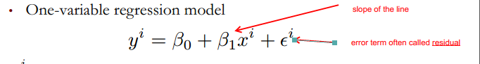

**\*\*\*\***error coefficient would be zero where the line fit the data points perfectly

see best fit straight line:

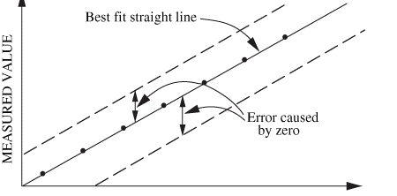

** One measure of the quality of a regression line is Sum of Squared Errors, or SSE:

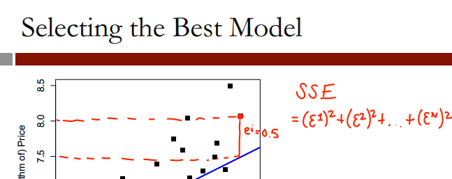

> model1=lm(Price ~AGST, data=wine)

> summary(model1)

Call:

lm(formula = Price ~ AGST, data = wine)

Summary of error terms

Residuals:

Min 1Q Median 3Q Max

AGST row is independent variable – avg growing season temperature

-0.78450 -0.23882 -0.03727 0.38992 0.90318

Coefficients:

Estimate Std. Error t value Pr(>|t|)

(Intercept) -3.4178 2.4935 -1.371 0.183710

AGST 0.6351 0.1509 4.208 0.000335 ***

---

Signif. codes: 0 ‘***’ 0.001 ‘**’ 0.01 ‘*’ 0.05 ‘.’ 0.1 ‘ ’ 1

Residual standard error: 0.4993 on 23 degrees of freedom

Multiple R-squared: 0.435, Adjusted R-squared: 0.4105

F-statistic: 17.71 on 1 and 23 DF, p-value: 0.000335

**SSE**  for model 1: 5.734875

multiple R – squared – R2 value for model

adjusted R – squared – R2 value for model

**adjusted R squared will decrease if a variable is added to model that doesn’t help**

SSE

[1] 5.734875

**model 2**

> summary(model2)

Call:

lm(formula = Price ~ AGST + HarvestRain, data = wine)

Residuals:

Min 1Q Median 3Q Max

-0.88321 -0.19600 0.06178 0.15379 0.59722

Coefficients:

Estimate Std. Error t value Pr(>|t|)

(Intercept) -2.20265 1.85443 -1.188 0.247585

AGST 0.60262 0.11128 5.415 1.94e-05 ***

HarvestRain -0.00457 0.00101 -4.525 0.000167 ***

---

Signif. codes: 0 ‘***’ 0.001 ‘**’ 0.01 ‘*’ 0.05 ‘.’ 0.1 ‘ ’ 1

Residual standard error: 0.3674 on 22 degrees of freedom

Multiple R-squared: 0.7074, Adjusted R-squared: 0.6808

F-statistic: 26.59 on 2 and 22 DF, p-value: 1.347e-06

**Notes:**

multiple R-squared increased from .435 to .7074

Adjusted R-squared increased from .4105 to .6808

SSE decreased from 5.734875 to 2.970373

SSE

[1] 2.970373

**Adding this variable significantly helped the model**

**model 3**

summary(model3)

Call:

lm(formula = Price ~ AGST + HarvestRain + WinterRain + Age +

FrancePop, data = wine)

Residuals:

Min 1Q Median 3Q Max

-0.48179 -0.24662 -0.00726 0.22012 0.51987

Coefficients:

Estimate Std. Error t value Pr(>|t|)

(Intercept) -4.504e-01 1.019e+01 -0.044 0.965202

AGST 6.012e-01 1.030e-01 5.836 1.27e-05 ***

HarvestRain -3.958e-03 8.751e-04 -4.523 0.000233 ***

WinterRain 1.043e-03 5.310e-04 1.963 0.064416 .

Age 5.847e-04 7.900e-02 0.007 0.994172

FrancePop -4.953e-05 1.667e-04 -0.297 0.769578

---

Signif. codes: 0 ‘***’ 0.001 ‘**’ 0.01 ‘*’ 0.05 ‘.’ 0.1 ‘ ’ 1

Residual standard error: 0.3019 on 19 degrees of freedom

Multiple R-squared: 0.8294, Adjusted R-squared: 0.7845

F-statistic: 18.47 on 5 and 19 DF, p-value: 1.044e-06

**Notes model 3 compared to 2:**

multiple R-squared increased from .7074 to .8294

Adjusted R-squared increased from .6808 to .7845

SSE decreased from 2.970373 to 1.732113

SSE

[1] 1.732113

**model 4 – using significant variables**

summary(model4)

Call:

lm(formula = Price ~ AGST + HarvestRain + WinterRain + Age, data = wine)

Residuals:

Min 1Q Median 3Q Max

-0.45470 -0.24273 0.00752 0.19773 0.53637

Coefficients:

Estimate Std. Error t value Pr(>|t|)

(Intercept) -3.4299802 1.7658975 -1.942 0.066311 .

AGST 0.6072093 0.0987022 6.152 5.2e-06 ***

HarvestRain -0.0039715 0.0008538 -4.652 0.000154 ***

WinterRain 0.0010755 0.0005073 2.120 0.046694 *

Age 0.0239308 0.0080969 2.956 0.007819 **

---

Signif. codes: 0 ‘***’ 0.001 ‘**’ 0.01 ‘*’ 0.05 ‘.’ 0.1 ‘ ’ 1

Residual standard error: 0.295 on 20 degrees of freedom

Multiple R-squared: 0.8286, Adjusted R-squared: 0.7943

F-statistic: 24.17 on 4 and 20 DF, p-value: 2.036e-07

Moneyball – predicting wins by run differential (variable RD)

winsreg=lm(W~RD,moneyball)

> summary(winsreg)

Call:

lm(formula = W ~ RD, data = moneyball)

Residuals:

Min 1Q Median 3Q Max

-14.2662 -2.6509 0.1234 2.9364 11.6570

Coefficients:

Estimate Std. Error t value Pr(>|t|)

(Intercept) 80.881375 0.131157 616.67 <2e-16 ***

RD 0.105766 0.001297 81.55 <2e-16 ***

---

Signif. codes: 0 ‘***’ 0.001 ‘**’ 0.01 ‘*’ 0.05 ‘.’ 0.1 ‘ ’ 1

Residual standard error: 3.939 on 900 degrees of freedom

Multiple R-squared: 0.8808, Adjusted R-squared: 0.8807

F-statistic: 6651 on 1 and 900 DF, p-value: < 2.2e-16

**This shows:**

1. strong model due to the R squared value of .8807

**Predicting Wins by OBP, SLG, and BA**

> summary(RunsReg)

Call:

lm(formula = RS ~ OBP + SLG + BA, data = moneyball)

Residuals:

Min 1Q Median 3Q Max

-70.941 -17.247 -0.621 16.754 90.998

Coefficients:

Estimate Std. Error t value Pr(>|t|)

(Intercept) -788.46 19.70 -40.029 < 2e-16 ***

OBP 2917.42 110.47 26.410 < 2e-16 ***

SLG 1637.93 45.99 35.612 < 2e-16 ***

BA -368.97 130.58 -2.826 0.00482 **

---

Signif. codes:

0 ‘***’ 0.001 ‘**’ 0.01 ‘*’ 0.05 ‘.’ 0.1 ‘ ’ 1

Residual standard error: 24.69 on 898 degrees of freedom

Multiple R-squared: 0.9302, Adjusted R-squared: 0.93

F-statistic: 3989 on 3 and 898 DF, p-value: < 2.2e-16

**Interpretation:**

* the BA (batting average) coefficient tells us that teams with a LOWER batting average will score more runs. **This is counter-intuitive**, and the cause is that the three predictor variables are highly correlated

This correlation is proven by the following analysis in R:

> moneynew=data.frame(moneyball$BA,moneyball$SLG,moneyball$OBP)

> cor(moneynew)

moneyball.BA moneyball.SLG moneyball.OBP

moneyball.BA 1.0000000 0.8140681 0.8540549

moneyball.SLG 0.8140681 1.0000000 0.8061539

moneyball.OBP 0.8540549 0.8061539 1.0000000

**read.csv**

* if a variable in the file starts with a number, R will put an “X” in front of it see yellow shaded area in table:

|  |  |
| --- | --- |
| **original name** | **R variable name** |
| SeasonEnd | SeasonEnd |
| Team | Team |
| Playoffs | Playoffs |
| W | W |
| PTS | PTS |
| oppPTS | oppPTS |
| FG | FG |
| FGA | FGA |
| 2P | X2P |
| 2PA | X2PA |
| 3P | X3P |
| 3PA | X3PA |
| FT | FT |
| FTA | FTA |
| ORB | ORB |
| DRB | DRB |
| AST | AST |
| STL | STL |
| BLK | BLK |
| TOV | TOV |

**Interpretation:**  based on the table below a logical assumption would be that if a team wins at least 42 games, they have a very good chance of making it to the playoffs

|  |  |  |
| --- | --- | --- |
|  | not in playoffs | in playoffs |
| Wins | 0 | 1 |
| 11 | 2 | 0 |
| 12 | 2 | 0 |
| 13 | 2 | 0 |
| 14 | 2 | 0 |
| 15 | 10 | 0 |
| 16 | 2 | 0 |
| 17 | 11 | 0 |
| 18 | 5 | 0 |
| 19 | 10 | 0 |
| 20 | 10 | 0 |
| 21 | 12 | 0 |
| 22 | 11 | 0 |
| 23 | 11 | 0 |
| 24 | 18 | 0 |
| 25 | 11 | 0 |
| 26 | 17 | 0 |
| 27 | 10 | 0 |
| 28 | 18 | 0 |
| 29 | 12 | 0 |
| 30 | 19 | 1 |
| 31 | 15 | 1 |
| 32 | 12 | 0 |
| 33 | 17 | 0 |
| 34 | 16 | 0 |
| 35 | 13 | 3 |
| 36 | 17 | 4 |
| 37 | 15 | 4 |
| 38 | 8 | 7 |
| 39 | 10 | 10 |
| 40 | 9 | 13 |
| 41 | 11 | 26 |
| 42 | 8 | 29 |
| 43 | 2 | 18 |
| 44 | 2 | 27 |
| 45 | 3 | 22 |
| 46 | 1 | 15 |
| 47 | 0 | 28 |
| 48 | 1 | 14 |
| 49 | 0 | 17 |
| 50 | 0 | 32 |
| 51 | 0 | 12 |
| 52 | 0 | 20 |
| 53 | 0 | 17 |
| 54 | 0 | 18 |
| 55 | 0 | 24 |
| 56 | 0 | 16 |
| 57 | 0 | 23 |
| 58 | 0 | 13 |
| 59 | 0 | 14 |
| 60 | 0 | 8 |
| 61 | 0 | 10 |
| 62 | 0 | 13 |
| 63 | 0 | 7 |
| 64 | 0 | 3 |
| 65 | 0 | 3 |
| 66 | 0 | 2 |
| 67 | 0 | 4 |
| 69 | 0 | 1 |
| 72 | 0 | 1 |

**Assumption:**

games in the NBA are won by scoring more points than the opponent. See if there is a strong correlation between wins and point differential by plotting wins against point differential. There is a very strong correlation between the two variables.

**Conclusion:** this supports that linear regression would be a good tool to predict wins based on points differential

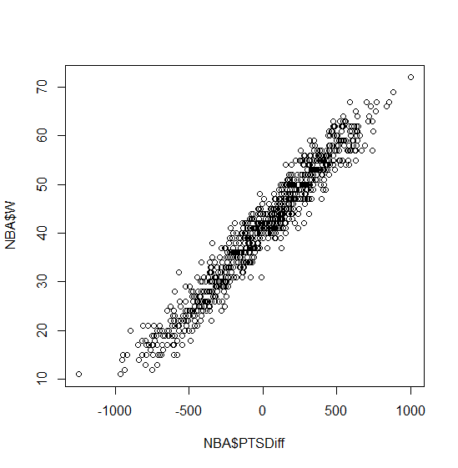

> summary(WinsReg)

Call:

lm(formula = NBA$W ~ NBA$PTSDiff, data = NBA)

Residuals:

Min 1Q Median 3Q Max

-9.7393 -2.1018 -0.0672 2.0265 10.6026

Coefficients:

Estimate Std. Error t value Pr(>|t|)

(Intercept) 4.100e+01 1.059e-01 387.0 <2e-16 ***

NBA$PTSDiff 3.259e-02 2.793e-04 116.7 <2e-16 ***

---

Signif. codes: 0 ‘***’ 0.001 ‘**’ 0.01 ‘*’ 0.05 ‘.’ 0.1 ‘ ’ 1

Residual standard error: 3.061 on 833 degrees of freedom

Multiple R-squared: 0.9423, Adjusted R-squared: 0.9423

F-statistic: 1.361e+04 on 1 and 833 DF, p-value: < 2.2e-16

**This linear model tells us that:**

Wins=41 + 0.326 * PTSDiff >= 42

PTSDIff >=

= 30.67

**Interpretation:** we need to score at least 31 more points than we allow to win at least 42 games

**Predicting points scored**

Call:

lm(formula = PTS ~ X2PA + X3PA + FTA + AST + ORB + DRB + TOV +

STL + BLK, data = NBA)

Residuals:

Min 1Q Median 3Q Max

-527.40 -119.83 7.83 120.67 564.71

Coefficients:

Estimate Std. Error t value Pr(>|t|)

(Intercept) -2.051e+03 2.035e+02 -10.078 <2e-16 ***

X2PA 1.043e+00 2.957e-02 35.274 <2e-16 ***

X3PA 1.259e+00 3.843e-02 32.747 <2e-16 ***

FTA 1.128e+00 3.373e-02 33.440 <2e-16 ***

AST 8.858e-01 4.396e-02 20.150 <2e-16 ***

ORB -9.554e-01 7.792e-02 -12.261 <2e-16 ***

DRB 3.883e-02 6.157e-02 0.631 0.5285

TOV -2.475e-02 6.118e-02 -0.405 0.6859

STL -1.992e-01 9.181e-02 -2.169 0.0303 *

BLK -5.576e-02 8.782e-02 -0.635 0.5256

---

Signif. codes: 0 ‘***’ 0.001 ‘**’ 0.01 ‘*’ 0.05 ‘.’ 0.1 ‘ ’ 1

Residual standard error: 185.5 on 825 degrees of freedom

Multiple R-squared: 0.8992, Adjusted R-squared: 0.8981

F-statistic: 817.3 on 9 and 825 DF, p-value: < 2.2e-16

**Interpretation:**

1. There is a linear relationship between points and these basketball statistics. This is a strong model, with a .8992 R-squared, but with some insignificant variables
2. Steals (STL) is not that significant – only one *
3. Defensive rebounds (DRB) and turnovers (TOV) is not significant at all

#compute the Sum of Squared Errors (SSE)

SSE= sum(PointsReg$residuals^2)

SSE

#28,394,314 - not very interpretable quantity

#calculate the root mean squared error - more interpretable

# and is more like the average error

#equal to the squared root of the SSE divided by the total number of observations

RMSE=sqrt(SSE/nrow(NBA))

RMSE

#184.4

#on average we make an error of 184.4 points

#this is not that bad

#when compared to the average number of points in a season

#184.4 compared to 8,370.24 points in the entire season

mean(NBA$PTS)

#8370.24

**Refining our model – remove insignificant variables**

* remove the least significant predictor first
* this is because the “P value” (.6859) is the largest

Call:

lm(formula = PTS ~ X2PA + X3PA + FTA + AST + ORB + DRB + TOV +

STL + BLK, data = NBA)

Residuals:

Min 1Q Median 3Q Max

-527.40 -119.83 7.83 120.67 564.71

Coefficients:

Estimate Std. Error t value Pr(>|t|)

(Intercept) -2.051e+03 2.035e+02 -10.078 <2e-16 ***

X2PA 1.043e+00 2.957e-02 35.274 <2e-16 ***

X3PA 1.259e+00 3.843e-02 32.747 <2e-16 ***

FTA 1.128e+00 3.373e-02 33.440 <2e-16 ***

AST 8.858e-01 4.396e-02 20.150 <2e-16 ***

ORB -9.554e-01 7.792e-02 -12.261 <2e-16 ***

DRB 3.883e-02 6.157e-02 0.631 0.5285

TOV -2.475e-02 6.118e-02 -0.405 0.6859

STL -1.992e-01 9.181e-02 -2.169 0.0303 *

BLK -5.576e-02 8.782e-02 -0.635 0.5256

---

Signif. codes: 0 ‘***’ 0.001 ‘**’ 0.01 ‘*’ 0.05 ‘.’ 0.1 ‘ ’ 1

Residual standard error: 185.5 on 825 degrees of freedom

Multiple R-squared: 0.8992, Adjusted R-squared: 0.8981

F-statistic: 817.3 on 9 and 825 DF, p-value: < 2.2e-16

The new model has the following summary:

* this new model almost the same R-squared: .8991 vs .8992

summary(PointsReg2)

Call:

lm(formula = PTS ~ X2PA + X3PA + FTA + AST + ORB + DRB + STL +

BLK, data = NBA)

Residuals:

Min 1Q Median 3Q Max

-526.79 -121.09 6.37 120.74 565.94

Coefficients:

Estimate Std. Error t value Pr(>|t|)

(Intercept) -2.077e+03 1.931e+02 -10.755 <2e-16 ***

X2PA 1.044e+00 2.951e-02 35.366 <2e-16 ***

X3PA 1.263e+00 3.703e-02 34.099 <2e-16 ***

FTA 1.125e+00 3.308e-02 34.023 <2e-16 ***

AST 8.861e-01 4.393e-02 20.173 <2e-16 ***

ORB -9.581e-01 7.758e-02 -12.350 <2e-16 ***

DRB 3.892e-02 6.154e-02 0.632 0.5273

STL -2.068e-01 8.984e-02 -2.301 0.0216 *

BLK -5.863e-02 8.749e-02 -0.670 0.5029

---

Signif. codes: 0 ‘***’ 0.001 ‘**’ 0.01 ‘*’ 0.05 ‘.’ 0.1 ‘ ’ 1

Residual standard error: 185.4 on 826 degrees of freedom

Multiple R-squared: 0.8991, Adjusted R-squared: 0.8982

F-statistic: 920.4 on 8 and 826 DF, p-value: < 2.2e-16

Now lets take out the next statistically insignificant variable, defensive rebounds (DRB)

* same R-squared: .8991

summary(PointsReg3)

Call:

lm(formula = PTS ~ X2PA + X3PA + FTA + AST + ORB + STL + BLK,

data = NBA)

Residuals:

Min 1Q Median 3Q Max

-523.79 -121.64 6.07 120.81 573.64

Coefficients:

Estimate Std. Error t value Pr(>|t|)

(Intercept) -2.015e+03 1.670e+02 -12.068 < 2e-16 ***

X2PA 1.048e+00 2.852e-02 36.753 < 2e-16 ***

X3PA 1.271e+00 3.475e-02 36.568 < 2e-16 ***

FTA 1.128e+00 3.270e-02 34.506 < 2e-16 ***

AST 8.909e-01 4.326e-02 20.597 < 2e-16 ***

ORB -9.702e-01 7.519e-02 -12.903 < 2e-16 ***

STL -2.276e-01 8.356e-02 -2.724 0.00659 **

BLK -3.882e-02 8.165e-02 -0.475 0.63462

---

Signif. codes: 0 ‘***’ 0.001 ‘**’ 0.01 ‘*’ 0.05 ‘.’ 0.1 ‘ ’ 1

Residual standard error: 185.4 on 827 degrees of freedom

Multiple R-squared: 0.8991, Adjusted R-squared: 0.8982

F-statistic: 1053 on 7 and 827 DF, p-value: < 2.2e-16

Take out the last significant variable, blocks (BLK):

* R-squared is still the same: .8991

summary(PointsReg4)

Call:

lm(formula = PTS ~ X2PA + X3PA + FTA + AST + ORB + STL, data = NBA)

Residuals:

Min 1Q Median 3Q Max

-523.33 -122.02 6.93 120.68 568.26

Coefficients:

Estimate Std. Error t value Pr(>|t|)

(Intercept) -2.033e+03 1.629e+02 -12.475 < 2e-16 ***

X2PA 1.050e+00 2.829e-02 37.117 < 2e-16 ***

X3PA 1.273e+00 3.441e-02 37.001 < 2e-16 ***

FTA 1.127e+00 3.260e-02 34.581 < 2e-16 ***

AST 8.884e-01 4.292e-02 20.701 < 2e-16 ***

ORB -9.743e-01 7.465e-02 -13.051 < 2e-16 ***

STL -2.268e-01 8.350e-02 -2.717 0.00673 **

---

Signif. codes: 0 ‘***’ 0.001 ‘**’ 0.01 ‘*’ 0.05 ‘.’ 0.1 ‘ ’ 1

Residual standard error: 185.3 on 828 degrees of freedom

Multiple R-squared: 0.8991, Adjusted R-squared: 0.8983

F-statistic: 1229 on 6 and 828 DF, p-value: < 2.2e-16

**comparing the Root Mean Squared Error of the two models:**

|  |
| --- |
| > #compute the Sum of Squared Errors (SSE) on new model  > SSE_4= sum(PointsReg4$residuals^2)  > SSE_4  [1] 28421465  >  > #equal to the squared root of the SSE divided by the total number of observations  > RMSE_4=sqrt(SSE_4/nrow(NBA))  > RMSE_4  [1] 184.493  > #root mean squared error difference between models are very small  > #which means we kept the same amount of error  > #original model RMSE:  > RMSE  [1] 184.4049 |
|  |
| |  | | --- | |  | |

**Validation: how well does the model fit test data?**

* R-squared from model (.8991) is the IN SAMPLE R-squared
* to get a measure of the predictions goodness of fit, we need to calculate the out of sample R-squared

|  |
| --- |
| > #Let's predict how many points will be scored in the 2012-2013 season using our model  > PointsPredictions=predict(PointsReg4,newdata=NBA_Test)  > #sum of PREDICTED amount - sum of ACTUAL points squared and summed  > SSE=sum((PointsPredictions-NBA_Test$PTS)^2)  > # sum of the average number of points minus the test actual number of points  > SST=sum((mean(NBA$PTS)-NBA_Test$PTS)^2)  > SSE  [1] 1079739  > SST  [1] 5765192  > R2=1-(SSE/SST)  > R2  [1] 0.8127142  >  > RMSE=sqrt(SSE/nrow(NBA_Test))  > # a little higher than the training data, but still reasonable  > RMSE  [1] 196.3723 |
|  |
| |  | | --- | |  |   **Factors – reference levels** |

However, by default R selects the first level alphabetically ("American Indian/Alaska Native") as the reference level of our factor instead of the most common level ("White"). Set the reference level of the factor by typing the following two lines in your R console:

pisaTrain$raceeth = relevel(pisaTrain$raceeth, "White")

pisaTest$raceeth = relevel(pisaTest$raceeth, "White")

**LM function tips**

It would be time-consuming to type all the variables, but R provides the shorthand notation "readingScore ~ ." to mean "predict readingScore using all the other variables in the data frame." The period is used to replace listing out all of the independent variables. As an example, if your dependent variable is called "Y", your independent variables are called "X1", "X2", and "X3", and your training data set is called "Train", instead of the regular notation:

LinReg = lm(Y ~ X1 + X2 + X3, data = Train)

You would use the following command to build your model:

LinReg = lm(Y ~ ., data = Train)

**Logorithmic dependent variables**

However, the dependent variable in our model is log(ILI), so PredTest1 would contain predictions of the log(ILI) value. We are instead interested in obtaining predictions of the ILI value. We can convert from predictions of log(ILI) to predictions of ILI via exponentiation, or the exp() function. The new code, which predicts the ILI value, is

PredTest1 = exp(predict(FluTrend1, newdata=FluTest))

## Obtaining AUC from a model in R

**How to obtain probabilities:**

Logistic regression:

predTrainLog = predict(spamLog, type="response")

CART tree:

predTrainCART = predict(spamCART)[,2]

Random Forest:

predTrainRF = predict(spamRF, type="prob")[,2]

Logistical Regression

Core principal: (know this!!!!!)

* positive coefficient INCREASE probability of 1

|  |  |  |
| --- | --- | --- |
| **Coefficient (** | **Logit** | **Relation to probability** |
| positive | increases | INCREASES the probability of 1 |
| negative | decreases | DECREASES the linear regression piece, which DECREASES the probability that y=1  OR INCREASES the probability of good care |

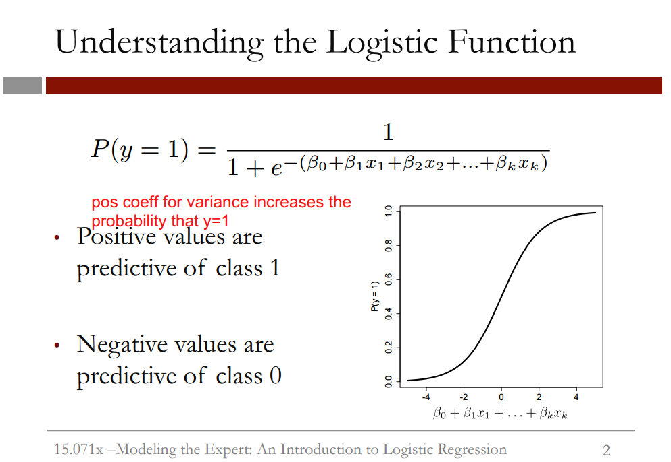

**Explanation of slide:**

* this graph shows the logistic response function for different values of the linear regression piece
* **NOTE:** the x axis always takes values between 0 and 1, as it’s a probability

**Relationship of coefficients to probabilities:**

|  |  |  |
| --- | --- | --- |
| **Coefficient (** | **Logit** | **Relation to probability** |
| positive | increases | INCREASES the probability of 1 |
| negative | decreases | DECREASES the linear regression piece, which DECREASES the probability that y=1  OR INCREASES the probability of good care |

## Threshold values

## 

* **sensitivity** is also called the “true positive rate”
* **specificity** is also called the “true negative rate”

**Relationship of sensitivity and specificity to threshold:**

|  |  |  |
| --- | --- | --- |
| **Threshold** | **Sensitivity** | **specificity** |
| **higher** | lower | higher |
| **lower** | higher | lower |

**Creating a confusion matrix in R**

#creating a confusion matrix where threshold=0.5

> #actual outcomes by predicted outcomes

> table(qualityTrain$PoorCare,predictTrain>0.5)

safasdf

**rows:** true outcome

**columns:** predicted outcome

FALSE TRUE

0 70 4

1 15 10

**Interpretation:**

* 70 cases we predicted good care, and they actually received good care
* 10 cases we predicted poor care and they actually received poor care
* model makes 4 mistakes where we say poor care (1) and it’s actually good care (0)
* model make 15 mistakes where we say good care (0) and it’s actually poor care

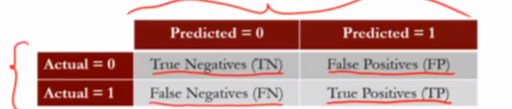

|  |
| --- |
| > table(qualityTrain$PoorCare,predictTrain>0.5)    FALSE TRUE  0 70 4  1 15 10  > #threshold= 0.5  > #sensitivity (true positive rate)= true positives/(true positives+false negatives)  > sensitivity= 10/(10+15)  > sensitivity  [1] 0.4  >  > #specificity (true negative rate)= true negatives/(true negatives+false positives)  > specificity=70/(70+4)  > specificity  [1] 0.9459459 |
|  |
| |  | | --- | | >  > #creating a confusion matrix where threshold=0.7  > #by increasing threshold, sensitivity goes down, specificity goes up  > #actual outcomes by predicted outcomes  > table(qualityTrain$PoorCare,predictTrain>0.7)    FALSE TRUE  0 73 1  1 17 8  >  > #threshold= 0.7  > #sensitivity (true positive rate)= true positives/(true positives+false negatives)  > sensitivity= 8/(8+17)  > sensitivity  [1] 0.32  >  > #specificity (true negative rate)= true negatives/(true negatives+false positives)  > specificity=73/(73+1)  > specificity  [1] 0.9864865 | |

|  |
| --- |
| > #creating a confusion matrix where threshold=0.2  > #by decreasing threshold, sensitivity goes up, specificity goes down  > #actual outcomes by predicted outcomes  > table(qualityTrain$PoorCare,predictTrain>0.2)    FALSE TRUE  0 54 20  1 9 16  >  > #threshold= 0.7  > #sensitivity (true positive rate)= true positives/(true positives+false negatives)  > sensitivity= 16/(16+9)  > sensitivity  [1] 0.64  >  > #specificity (true negative rate)= true negatives/(true negatives+false positives)  > specificity=54/(54+20)  > specificity  [1] 0.7297297 |
|  |
| |  | | --- | | > | |

## Interpretation of ROC curve

**learnings from below**

* As always, we prefer **a lower threshold in cases where false negatives are more costly than false positives**, since we will make fewer negative predictions.
* “high confidence” means minimizing false positives

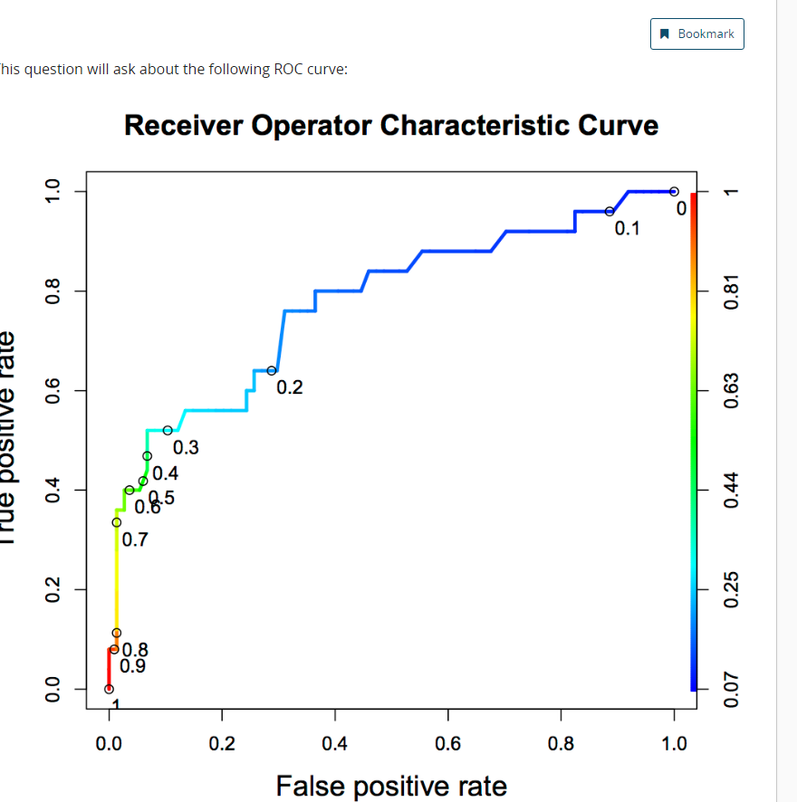

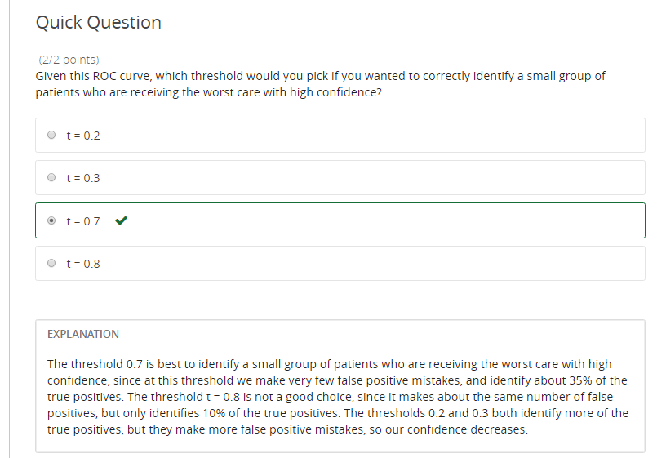

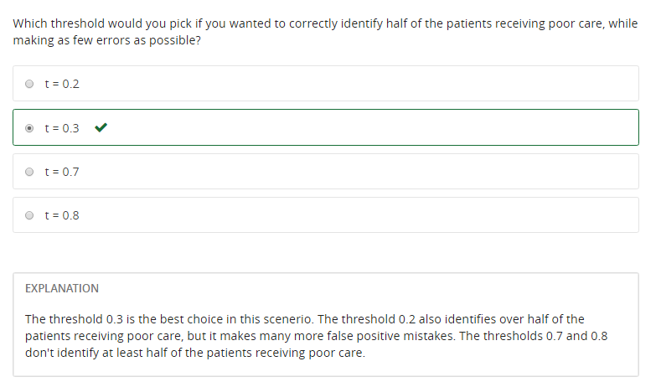

Framingham

table(test$TenYearCHD,predictTest>0.5)

FALSE TRUE

0 1069 6

1 187 11

**Interpretation:**

accuracy of model:

total predictions we get right divided by total number of observations

= (1069+11)/(1069+6+187+11)

**84.84% accurate**

**Compare this model to baseline**

baseline=1069+6/(1069+6+187+11)

=84.44%

So model is barely better than baseline

**predict out of sample AUC**

> #predict out of sample AUC

> library(ROCR)

> ROCRpred=(prediction(predictTest,test$TenYearCHD))

> as.numeric(performance(ROCRpred,"auc")@y.values)

[1] 0.7421095

**Interpretation:** the model can differentiate between high risk patients and low risk patients 74.11% of the time, which is a pretty good number.

Classification and Regression Trees (CART)

Video 6- Cross validation

Helps us to make sure we’re selecting a good parameter value.

k-fold cross validation – one way to properly select the parameter value

* cp – Complexity Parameter – measures complexity between model complexity and accuracy on the training set
* smaller cp value leads to a bigger tree, but might overfit

The following code will find the value for us:

library(caret)

library(e1071)

numFolds=trainControl(method="cv", number=10)

#pick possible values for cp value

#seq from 0.01 to 0.5 in increments of 0.01

cpGrid=expand.grid(.cp=seq(0.01,0.5,0.01))

train(Reverse ~ Circuit+ Issue + Petitioner + Respondent+ LowerCourt + Unconst,data=Train,method="rpart",trControl=numFolds,tuneGrid=cpGrid)

We feed this cp value of 0.19 back into the ***rpart*** function

StevensTreeCV=rpart(Reverse ~ Circuit+ Issue + Petitioner + Respondent+ LowerCourt + Unconst,data=Train,method="class",cp=0.19)

See output of train for

**Output of train:**

CART

396 samples

8 predictor

2 classes: '0', '1'

No pre-processing

Resampling: Cross-Validated (10 fold)

Summary of sample sizes: 356, 356, 356, 357, 356, 357, ...

Resampling results across tuning parameters:

cp Accuracy Kappa

0.01 0.6285897 0.233356351

0.02 0.6209615 0.221777855

0.03 0.6083333 0.198904931

0.04 0.6236538 0.233636598

0.05 0.6337821 0.259912375

0.06 0.6440385 0.282622850

0.07 0.6440385 0.282622850

0.08 0.6440385 0.282622850

0.09 0.6440385 0.282622850

0.10 0.6440385 0.282622850

0.11 0.6440385 0.282622850

0.12 0.6440385 0.282622850

0.13 0.6440385 0.282622850

0.14 0.6440385 0.282622850

0.15 0.6440385 0.282622850

0.16 0.6440385 0.282622850

0.17 0.6440385 0.282622850

0.18 0.6440385 0.282622850

0.19 0.6440385 0.282622850

0.20 0.6265385 0.235762947

0.21 0.5832692 0.123807906

0.22 0.5630128 0.068498716

0.23 0.5453846 0.008163265

0.24 0.5453846 0.008163265

0.25 0.5453846 0.000000000

0.26 0.5453846 0.000000000

0.27 0.5453846 0.000000000

0.28 0.5453846 0.000000000

0.29 0.5453846 0.000000000

0.30 0.5453846 0.000000000

0.31 0.5453846 0.000000000

0.32 0.5453846 0.000000000

0.33 0.5453846 0.000000000

0.34 0.5453846 0.000000000

0.35 0.5453846 0.000000000

0.36 0.5453846 0.000000000

0.37 0.5453846 0.000000000

0.38 0.5453846 0.000000000

0.39 0.5453846 0.000000000

0.40 0.5453846 0.000000000

0.41 0.5453846 0.000000000

0.42 0.5453846 0.000000000

0.43 0.5453846 0.000000000

0.44 0.5453846 0.000000000

0.45 0.5453846 0.000000000

0.46 0.5453846 0.000000000

0.47 0.5453846 0.000000000

0.48 0.5453846 0.000000000

0.49 0.5453846 0.000000000

0.50 0.5453846 0.000000000

Accuracy was used to select the optimal model using the largest value.

The final value used for the model was cp = 0.19.

This code helps us to select the optimum complexity parameter as depicted in the graph:

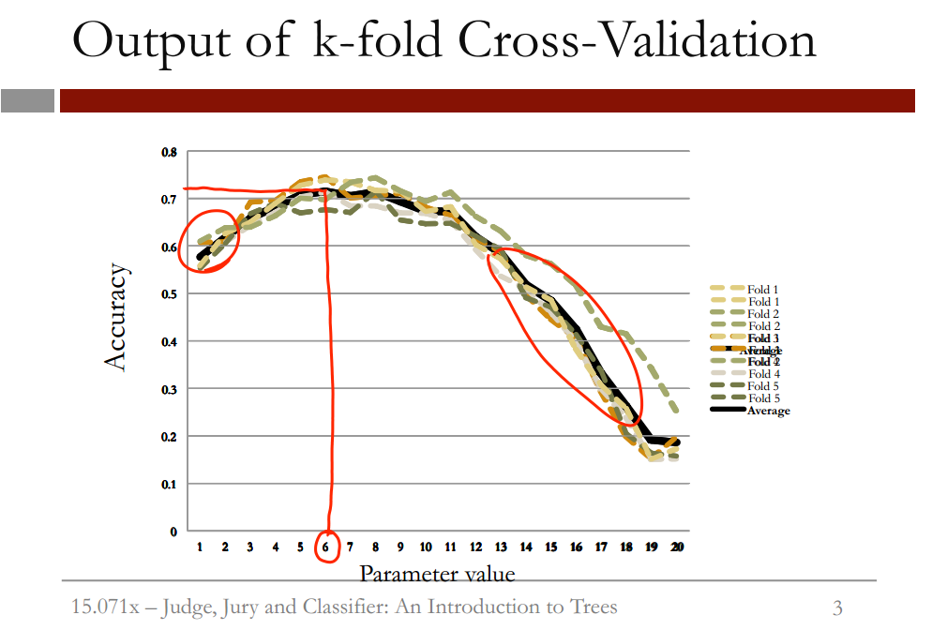

D2Hawkeye

* improve healthcare risk management
* **improve quality of cost predictions**

Use claims, demographics, and for a 3 year period (2001-2003) and then make predictions on 2004-2005.

**Variables used**

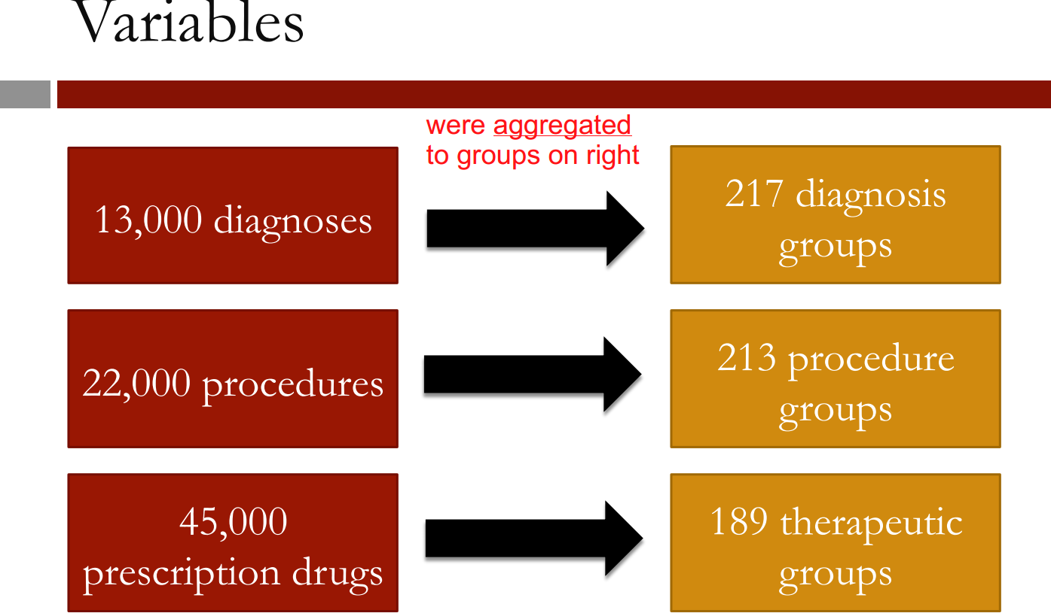

df

CART models

* the GOAL is to have your CART model have a better accuracy and LESS of a penalty than the baseline, which is below:

**baseline method**

|  |
| --- |
| > #accuracy  > #sum of diagnosis / total number of observations  > (110138+10721+2774+1539+104)/nrow(ClaimsTest)  [1] 0.6838135  > #penalty error for the BASELINE method  > #sum penalty matrix and divide by total number  > #of observations  > #goal is the create a CART model  > #with accuracy higher than 68% and  > # a penalty error lower than .74  > sum(as.matrix(table(ClaimsTest$bucket2009,ClaimsTest$bucket2008))*PenaltyMatrix)/nrow(ClaimsTest)  [1] 0.7386055 |
|  |
| |  | | --- | | > | |

**Cart model 1**

> #accuracy

> (114141+16102+118+201)/nrow(ClaimsTest)

[1] 0.7126669

> #penalty error:

> sum(as.matrix(table(ClaimsTest$bucket2009,PredictTest))*PenaltyMatrix)/nrow(ClaimsTest)

[1] 0.7578902

**Cart model 2 – reduced accuracy, but less penalty error**

> #accuracy of revised model

> (94310+18942+4692+636+2)/nrow(ClaimsTest)

[1] 0.6472746

>

> #penalty error:

> sum(as.matrix(table(ClaimsTest$bucket2009,PredictTest))*PenaltyMatrix)/nrow(ClaimsTest)

[1] 0.6418161

**Notes to fill in**

* what is a classification problem and when are they used

Regression trees

* at each leaf of the tree, the AVERAGE is reported

explain the following

* compare linear regression with regression trees
* discuss the “cp” parameter
* apply cross-validation to regression trees

Unit 4 recitation predicting median housing prices per census tract

* build model on how prices vary by location across a region
* we will aim to predict the **MEDV**, or median value of a home in thousands of dollars
* we will compare the performance of linear regression, regression trees, and regression trees with cross-validation

**Understanding how CART model sections off housing price areas:**

Understanding the dataset:

* Each entry corresponds to a **census tract**, a statistical

division of the area that is used by researchers to

break down towns and cities.

•  There will usually be multiple census tracts per town.

•  LON and LAT are the longitude and latitude of the

center of the census tract.

•  **MEDV** is the median value of owner-occupied

homes,in thousands of dollars.

Understanding the data

15.071x –Modeling the Expert: An Introduction to Logistic Regression 9

•  CRIM is the per capita crime rate

•  ZN is related to how much of the land is zoned for

large residential properties

•  INDUS is proportion of area used for industry

•  CHAS is 1 if the census tract is next to the Charles

River

•  NOX is the concentration of nitrous oxides in the air

•  RM is the average number of rooms per dwelling

•  AGE is the proportion of owner-occupied units built

before 1940

•  DIS is a measure of how far the tract is from centers

of employment in Boston

•  RAD is a measure of closeness to important

highways

•  TAX is the property tax rate per $10,000 of value

•  PTRATIO is the pupil-teacher ratio by town

simplified code in R to build the tree – note *minbucket* parameter:

# Simplify tree by increasing minbucket

latlontree = rpart(MEDV ~ LAT + LON, data=boston, minbucket=50)

plot(latlontree)

text(latlontree)

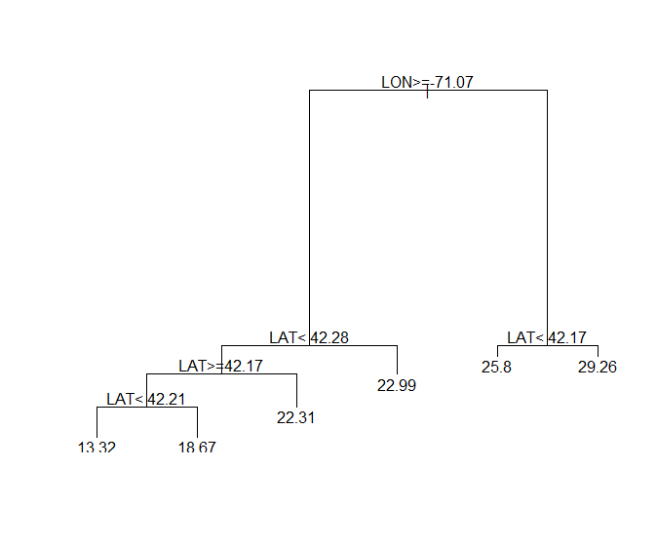

compare splits in tree – to how the data gets carved out on the plot.

The model correctly identified the low priced area not highlighted in red. The areas not highlighted in red correspond to low priced areas, in red are high priced areas.

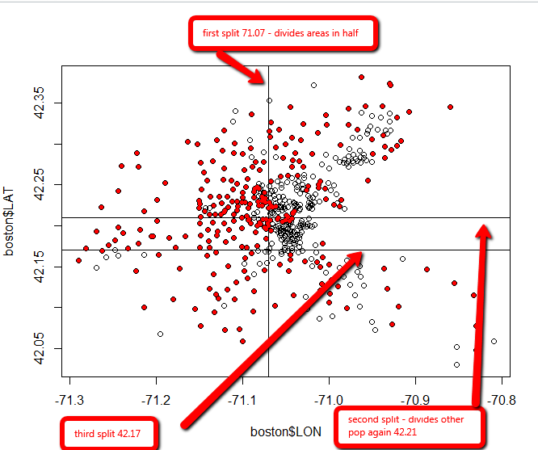

Predict using linear regression

# Split the data

library(caTools)

set.seed(123)

split = sample.split(boston$MEDV, SplitRatio = 0.7)

train = subset(boston, split==TRUE)

test = subset(boston, split==FALSE)

# Create linear regression

linreg = lm(MEDV ~ LAT + LON + CRIM + ZN + INDUS + CHAS + NOX + RM + AGE + DIS + RAD + TAX + PTRATIO, data=train)

summary(linreg)

summary(linreg)

**Interpretation:**

* LAT and LON are not important
* CRIM(crime) is very important
* ZN(zoning for residential properties) MAY be important
* CHAS(proximity to Charles River) is important
* NOX (air pollution) is very important. **Note the negative coefficient-** this means the higher the independent variable, NOX, the lower the dependent variable, median housing price.
* others like RM, AGE, DIS, RAD, TAC and PT ratio are also important

Some of these may be correlated, so we can’t yet make any hard assumptions

Call:

lm(formula = MEDV ~ LAT + LON + CRIM + ZN + INDUS + CHAS + NOX +

RM + AGE + DIS + RAD + TAX + PTRATIO, data = train)

Residuals:

Min 1Q Median 3Q Max

-14.511 -2.712 -0.676 1.793 36.883

Coefficients:

Estimate Std. Error t value Pr(>|t|)

(Intercept) -2.523e+02 4.367e+02 -0.578 0.5638

LAT 1.544e+00 5.192e+00 0.297 0.7664

LON -2.987e+00 4.786e+00 -0.624 0.5329

CRIM -1.808e-01 4.390e-02 -4.118 4.77e-05 ***

ZN 3.250e-02 1.877e-02 1.731 0.0843 .

INDUS -4.297e-02 8.473e-02 -0.507 0.6124

CHAS 2.904e+00 1.220e+00 2.380 0.0178 *

NOX -2.161e+01 5.414e+00 -3.992 7.98e-05 ***

RM 6.284e+00 4.827e-01 13.019 < 2e-16 ***

AGE -4.430e-02 1.785e-02 -2.482 0.0135 *

DIS -1.577e+00 2.842e-01 -5.551 5.63e-08 ***

RAD 2.451e-01 9.728e-02 2.519 0.0122 *

TAX -1.112e-02 5.452e-03 -2.040 0.0421 *

PTRATIO -9.835e-01 1.939e-01 -5.072 6.38e-07 ***

---

Signif. codes: 0 ‘***’ 0.001 ‘**’ 0.01 ‘*’ 0.05 ‘.’ 0.1 ‘ ’ 1

Residual standard error: 5.595 on 350 degrees of freedom

Multiple R-squared: 0.665, Adjusted R-squared: 0.6525

F-statistic: 53.43 on 13 and 350 DF, p-value: < 2.2e-16

Building a tree

# Create a CART model

tree = rpart(MEDV ~ LAT + LON + CRIM + ZN + INDUS + CHAS + NOX + RM + AGE + DIS + RAD + TAX + PTRATIO, data=train)

prp(tree)

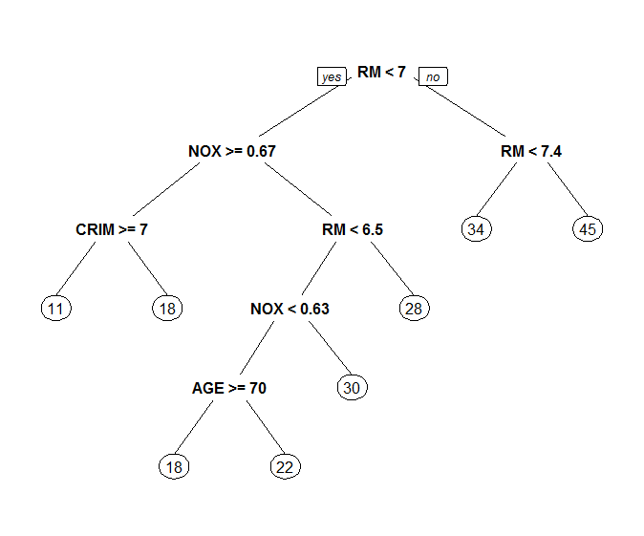

Interpretation of tree:

* doing different things than linear regression:
  + rooms are most important split – appears three times
  + pollution (NOX) is important
  + the DIS variable doesn’t appear at all

Comparing performance of tree and linear regression

* linear regression performed better (lower SSE)

Linear regression

> # Make predictions

> linreg.pred = predict(linreg, newdata=test)

> #compute sum of squared errors

> linreg.sse = sum((linreg.pred - test$MEDV)^2)

> linreg.sse

[1] 3037.088

Trees

> # Create a CART model

> tree = rpart(MEDV ~ LAT + LON + CRIM + ZN + INDUS + CHAS + NOX + RM + AGE + DIS + RAD + TAX + PTRATIO, data=train)

> prp(tree)

>

> # Make predictions

> tree.pred = predict(tree, newdata=test)

> tree.sse = sum((tree.pred - test$MEDV)^2)

> tree.sse

[1] 4328.988

The CP parameter

* large CP value encourages small trees
* small CP value encourages large trees
* smaller CP value might overfit
* like adjusted R2 or AIC, measure the tradeoff between complexity and accuracy on the training set

Cross-validation on original tree

Define 10 folds we are using for cross-validation:

# Number of folds

tr.control = trainControl(method = "cv", number = 10)

We want to test 10 values for the cp parameter, from 0.000 to 0.010:

> # cp values

> cp.grid = expand.grid( .cp = (0:10)*0.001)

> #10 values we are tesing for cp:

> 0:10 * 0.001

[1] 0.000 0.001 0.002 0.003 0.004 0.005 0.006 0.007 0.008 0.009 0.010

perform cross-validation:

note parameters:

**method-** = rpart – we want to cross-validate a CART model

**trcontrol**=tr.control – which is the output of our trainControl function

**tuneGrid**=the output of our expand.grid function, which are the cp values we want to try

# Cross-validation

tr = train(MEDV ~ LAT + LON + CRIM + ZN + INDUS + CHAS + NOX + RM + AGE + DIS + RAD + TAX + PTRATIO, data = train, method = "rpart", trControl = tr.control, tuneGrid = cp.grid)

Output of cross-validation:

**cp**: cp value that was tested

> tr

CART

364 samples

15 predictor

No pre-processing

Resampling: Cross-Validated (10 fold)

Summary of sample sizes: 327, 328, 327, 326, 329, 328, ...

Resampling results across tuning parameters:

cp RMSE Rsquared

0.000 5.016424 0.7024299

0.001 5.019249 0.7021209

0.002 4.982503 0.7053810

0.003 4.954787 0.7052078

0.004 5.017375 0.6997889

0.005 5.012303 0.6989719

0.006 5.001139 0.7025319

0.007 4.986804 0.7055931

0.008 4.990416 0.7045750

0.009 4.970749 0.7080678

0.010 4.970749 0.7080678

RMSE was used to select the optimal model using the smallest value.

The final value used for the model was cp = 0.003.

Unit 4 assignment 4 – predicting life expectancy with Census data

Tree one

> state.CART=rpart(Life.Exp ~. , data=statedata)

> prp(state.CART)

> state.CART.pred=predict(state.CART,data=statedata)

> SSE.CART=sum((state.CART.pred-statedata$Life.Exp)^2)

> SSE.CART

[1] 28.99848

Tree two

> #remake tree, but make bigger

> state.CART5=rpart(Life.Exp ~. , data=statedata,minbucket=5)

> prp(state.CART5)

>

> state.CART5.pred=predict(state.CART5,data=statedata)

> SSE.CART5=sum((state.CART5.pred-statedata$Life.Exp)^2)

> SSE.CART5

[1] 23.64283

Tree three with cross-validation

> #cross-fold validation

> library(caret)

> library(e1071)

> numFolds=trainControl(method="cv", number=10)

> #pick possible values for cp value

> #seq from 0.01 to 0.5 in increments of 0.01

> cpGrid=expand.grid(.cp=seq(0.01,0.5,0.01))

> set.seed(111)

> train(Life.Exp ~ .,data=statedata,method="rpart",trControl=numFolds,tuneGrid=cpGrid)

>

>

> #create tree with cp value

> statetreeCV=rpart(Life.Exp ~ .,data=statedata,cp=0.12)

> prp(statetreeCV)

>

> ##SSE

> statetreeCV.pred = predict(statetreeCV, data=statedata)

> tree.sse = sum((statetreeCV.pred - statedata$Life.Exp)^2)

> tree.sse

[1] 32.86549

Tree four with cross validation and Area dependent variable only:

statetreeCV.area=rpart(Life.Exp ~ Area,data=statedata,cp=0.02)

> prp(statetreeCV.area)

> 51e3

[1] 51000

> statetreeCV.area.pred = predict(statetreeCV.area, data=statedata)

> tree.CV.sse = sum((statetreeCV.area.pred - statedata$Life.Exp)^2)

> statetreeCV.area.pred = predict(statetreeCV.area, data=statedata)

> tree.CV.sse = sum((statetreeCV.area.pred - statedata$Life.Exp)^2)

> tree.CV.sse

[1] 44.26817

Random Forests

building random forests in R

The RandomForest function does NOT have a method argument, so to do a classification problem, the dependent variable must be a factor

example:

Train$Reverse=as.factor(Train$Reverse)

Text analytics

Bag of Words

A Bag of Words

15.071x –Turning Tweets Into Knowledge: An Introduction to Text Analytics 1

•  Fully understanding text is difficult

•  Simpler approach:

Count the number of times each words appears

•  “This course is great. I would recommend this course

to my friends.”

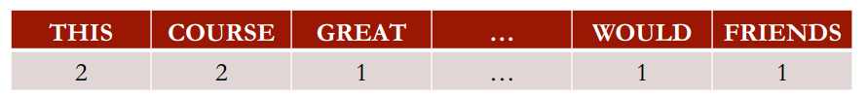

**Preprocessing**

1. remove irregularities
   1. unmeaningful punctuation
   2. change all words to all upper or all lower case
2. remove stop words such as *is, that, which*. **Reason**: unlikely to improve machine learning prediction quality
3. stemming – reducing words to their root or stem form

TM package

* concept introduced by package is that of a ­corpus. A corpus is a collection of documents
* DocumentTermMatrix – generate a matrix where rows are tweets, columns are words in the tweets

|  |  |  |  |
| --- | --- | --- | --- |
|  | * word1 | * word2 | * word3 |
| * tweets |  |  |  |
| * tweets |  |  |  |

**Example:**

frequencies

<<DocumentTermMatrix (documents: 1181, terms: 3309)>>

Non-/sparse entries: 8964/3898965

Sparsity : 100%

Maximal term length: 115

Weighting : term frequency (tf)

> inspect(frequencies[1000:1005,505:515])

<<DocumentTermMatrix (documents: 6, terms: 11)>>

Non-/sparse entries: 1/65

Sparsity : 98%

Maximal term length: 9

Weighting : term frequency (tf)

Terms

Docs cheaper check cheep cheer cheerio cherylcol chief chiiiiqu child children chile

character(0) 0 0 0 0 0 0 0 0 0 0 0

character(0) 0 0 0 0 0 0 0 0 0 0 0

character(0) 0 0 0 0 0 0 0 0 0 0 0

character(0) 0 0 0 0 0 0 0 0 0 0 0

character(0) 0 0 0 0 0 0 0 0 0 0 0

character(0) 0 0 0 1 0 0 0 0 0 0 0

* we must remove words that are “sparse” in the data

1. more terms take greater computation
2. more terms – more independent variables – will affect how the model will generalize

Predicting sentiment using models

* Random forest
  + these models will take significantly longer to build as there are many more independent variables – **300** in the twitter dataset

Text analytics HW – Automating reviews in medicine

Dataset

**classifications done by manual review initially:**

These labels were obtained by two people reviewing each search result and accessing the actual paper if necessary, as part of a literature review of clinical trials testing drug therapies for advanced and metastatic breast cancer.

|  |  |  |
| --- | --- | --- |
| **Variable** | **Description** |  |
| Title | Title of paper retrieved in a Pubmeb search |  |
| Abstract | The abstract of paper retrieved in Pubmed search |  |
| Trial | Is paper a clinical trial testing a drug therapy for cancer |  |

Clustering and recommendation systems

Collaborative versus content based filtering..

Clustering

* clustering does NOT predict anything
* clustering can be used to group data into similar groups
* prediction methods can then be used on these similar groups to improve prediction rates

How does clustering work?

* by finding the distance between points
* methods:
  + Euclidian distance
  + Manhattan distance
  + Maximum coordinate distance

Hierarchical clustering

two steps

1. compute the distances between the points
2. cluster the points

Clustering in R

* to perform clustering, we need to convert our data into a vector

Case study problems

Unit 5 hw 2 – predicting is a PubMed paper is a clinical trial or not

|  |  |  |  |
| --- | --- | --- | --- |
|  | Total population | predicted positive | predictive negative |
| true condition | condition positive  Paper IS a trial paper | TRUE POSITIVE  Paper is predicted a trial paper and it is | FALSE POSITIVE  Paper is predicted a trial paper and it is NOT |
| condition negative  Paper is NOT a trial paper | FALSE NEGATIVE  Paper is predicted a trial paper and it is NOT a trial paper | TRUE NEGATIVE  Paper is NOT a trial paper and it is predicted not a trial paper |

General model fitting

Indicators of overfitting:

Nearly perfect accuracy and AUC on the training set and far-from-perfect performance on the testing set.

Linear optimization

What is it?

a mathematical method which solves for a series of DECISIONS, in order to minimize or maximize an OBJECTIVE, subject to CONSTRAINTS.

Examples;

* Airlines – maximize revenue. decisions: how many of each class set to sell. Constraints: airplane capacity, demand of each seat class
* Radiation therapy: problem: maximize the radiation dose to tumor. minimize doses to healthy structures. constraints: dose to tumor must be at least 7Gr. Dose to spine must be at most 5Gr, dose to healthy structures must be at most 3 Gr.

Wikipedia definition:

**Linear programming** (LP; also called **linear optimization**) is a method to achieve the best outcome (such as maximum profit or lowest cost) in a mathematical model whose requirements are represented by **linear** relationships.

Gasoline problem

## **GASOLINE BLENDING**

One of the earliest and most successful applications of linear optimization was in the oil industry in the 1950s. According to Bill Drew, the former manager of research for Exxon Mobil, the company used linear optimization to "schedule our tanker fleets, design port facilities, blend gasoline, create financial models, you name it."  In this problem, we'll use optimization to blend gasoline. (While the application of this problem is real, the data that we will be using here has been created for this problem.)

Gasoline blending occurs in oil refineries, where crude oil is processed and refined into more useful products, such as gasoline and diesel fuel. We will consider three products: super gasoline, regular gasoline, and diesel fuel. These can be made by mixing three different types of crude oil: crude 1, crude 2, and crude 3. Each product is distinguished by its octane rating, which measures the quality of the fuel, and its iron content, which is a contaminant in the gas. The crude oils each have an octane rating and iron content as well. The following table shows the required octane ratings and iron contents for each of the products, as well as the known octane ratings and iron contents of each of the crude oils:

|  |  |  |
| --- | --- | --- |
| **Product or Oil** | **Octane Rating** | **Iron Content** |
| Super Gasoline | at least 10 | no more than 1 |
| Regular Gasoline | at least 8 | no more than 2 |
| Diesel Fuel | at least 6 | no more than 1 |
| Crude 1 | 12 | 0.5 |
| Crude 2 | 6 | 2.0 |
| Crude 3 | 8 | 3.0 |

The gasoline produced must meet these standards for octane ratings and iron content. The octane rating and iron content of a product is the weighted average of the octane rating and iron content of the crude oils used to produce it. For example, if we produce super gasoline using 20 barrels of Crude 1, 5 barrels of Crude 2, and 10 barrels of Crude 3, the Octane Rating of the super gasoline would be:

(20*12 + 5*6 + 10*8)/35 = 10 🡨-------- **Constraint**

The numerator is the number of barrels of Crude 1 used times the octane rating of Crude 1, plus the number of barrels of Crude 2 used times the octane rating of Crude 2, plus the number of barrels of Crude 3 used times the octane rating of Crude 3. The denominator is the total number of barrels used.

Similarly, the iron content of the super gasoline would be:

(20*0.5 + 5*2.0 + 10*3.0)/35 = 1.43 🡨------- **Constraint**

The objective of the oil company is to maximize profit. The following table gives the sales price (revenue) for one barrel of each of the products:

|  |  |
| --- | --- |
| **Product** | **Sales Price** |
| Super Gasoline | $70 |
| Regular Gasoline | $60 |
| Diesel Fuel | $50 |

And the following table gives the purchase price for one barrel of each of the crude oils:

|  |  |
| --- | --- |
| **Oil** | **Purchase Price** |
| Crude 1 | $45 |
| Crude 2 | $35 |
| Crude 3 | $25 |

We would like to maximize the amount made by selling the products, minus the amount it costs to buy the crude oils.

The company can only buy 5,000 barrels of each type of crude oil, and can process no more than 14,000 barrels total of crude oil. One barrel of crude oil makes one barrel of gasoline or fuel (nothing is lost in the conversion).

How many barrels of each type of crude oil should the company use to make each product? Formulate this problem as a linear optimization problem, and solve it in LibreOffice (or in the spreadsheet software you are using). The first problem below asks about the formulation, and the second problem asks about the solution. So if you get stuck in formulating the problem, try working through Problem 1 below.

HINT: When trying to solve this problem, your solver might complain that it is nonlinear. Be careful how you construct the octane and iron constraints. If x, y, and z are variables, and you are trying to add the constraint:

*12x+6y+8zx+y+z≥10*

It needs to be formulated as:

*12x+6y+8z≥10(x+y+z)*

This is because you can only add variables in linear constraints. Note that this is the same constraint - we just multiplied both sides of the denominator of the fraction.

Useful packages used in analysis

|  |  |
| --- | --- |
| caTools |  |
| caret |  |
| e1071 |  |

caTools

**Example**

> #used to split dataset into training (75%)

> #and testing (25%)

> split=sample.split(quality$PoorCare,SplitRatio=0.75)

> split

[1] TRUE TRUE TRUE TRUE FALSE TRUE FALSE TRUE FALSE FALSE TRUE FALSE TRUE TRUE

[15] TRUE TRUE TRUE TRUE TRUE TRUE TRUE TRUE TRUE TRUE FALSE TRUE TRUE TRUE

[29] TRUE FALSE FALSE FALSE FALSE TRUE TRUE TRUE FALSE TRUE TRUE TRUE FALSE FALSE

[43] TRUE TRUE FALSE TRUE FALSE TRUE FALSE TRUE TRUE FALSE FALSE TRUE TRUE TRUE

[57] TRUE TRUE TRUE TRUE TRUE TRUE TRUE TRUE TRUE FALSE TRUE TRUE TRUE TRUE

[71] FALSE TRUE TRUE TRUE TRUE TRUE TRUE TRUE TRUE TRUE TRUE TRUE TRUE FALSE

[85] TRUE TRUE TRUE TRUE TRUE TRUE TRUE TRUE TRUE FALSE TRUE TRUE TRUE TRUE

[99] TRUE TRUE TRUE TRUE TRUE FALSE TRUE TRUE TRUE FALSE TRUE FALSE FALSE TRUE

[113] TRUE FALSE TRUE TRUE TRUE FALSE TRUE TRUE FALSE TRUE TRUE FALSE TRUE TRUE

[127] FALSE TRUE TRUE TRUE FALSE

>

>

> #create training and testing sets

> #create train

> qualityTrain=subset(quality,split==TRUE)

> qualityTest=subset(quality,split==FALSE)

R cookbook section

* be VERY careful with logical operators. These two lines yield much different results:

**Correct:**

ham=subset(emailsSparse,spam==0)

**incorrect:**

ham=subset(emailsSparse,spam=0)

Adding column names to an existing data frame:

# Add column names

colnames(movies) = c("ID", "Title", "ReleaseDate", "VideoReleaseDate", "IMDB", "Unknown", "Action", "Adventure", "Animation", "Childrens", "Comedy", "Crime", "Documentary", "Drama", "Fantasy", "FilmNoir", "Horror", "Musical", "Mystery", "Romance", "SciFi", "Thriller", "War", "Western")

To remove a variable from a dataset:

# Remove unnecessary variables

movies$ID = NULL

Set NA values to zeros

# Those NAs are really 0s, and we can replace them easily

intlall[is.na(intlall)] = 0

Convert a string to a date variable using the *strptime* function

str(mvt)

'data.frame': 191641 obs. of 3 variables:

$ Date : chr "12/31/12 23:15" "12/31/12 22:00" "12/31/12 22:00" "12/31/12 22:00" ...

$ Latitude : num 41.8 41.9 42 41.8 41.8 ...

$ Longitude: num -87.6 -87.7 -87.8 -87.7 -87.6 ...

> mvt$Date = strptime(mvt$Date, format="%m/%d/%y %H:%M")

Merge function – combining two datasets –

first argument – first data source

second argument – second data source

third argument(by) – the variable you want to merge on

murderMap = merge(statesMap, murders, by="region")

Study todo’s

* write up how to measure accuracy and evaluation methods for all methodologies covered so far
* review clustering theory
* review logistic regression lectures and code
* work through at least 2 tree homeworks

Appendix – Useful resources found through course

Medical resources

National Center for BioTechnology Information (NCBI). This is part of the United States National Library of Medicine (NLM), a branch of the National Institute of Health (NIH)

<http://www.ncbi.nlm.nih.gov/>

Natural language processing

<http://language.worldofcomputing.net/nlp-overview/natural-language-processing-overview.html>

great article on text mining in general in R and further details of the DTM (document term matrix):

<http://www.r-bloggers.com/text-mining-the-complete-works-of-william-shakespeare/>

Statistical methods using R

<http://www.r-bloggers.com/in-depth-introduction-to-machine-learning-in-15-hours-of-expert-videos/>

General R programming

<https://www.datacamp.com/community/tutorials/15-easy-solutions-data-frame-problems-r>

Statistical learning concepts

GREAT explanation

<https://en.wikipedia.org/wiki/Sensitivity_and_specificity>